**COVERAGE TEST DOCUMENTATION**

With our test we covered all model classes with an average of 94%.  
We covered all the critical point in this project like StateManager, GodFactory and CheckingUtility; we considered this classes critical because power of god, flow of the game and the calculation of possible action are what characterized this game. Part of classes like TurnManager, LobbyManager are low covered because we didn’t consider getter and setter.

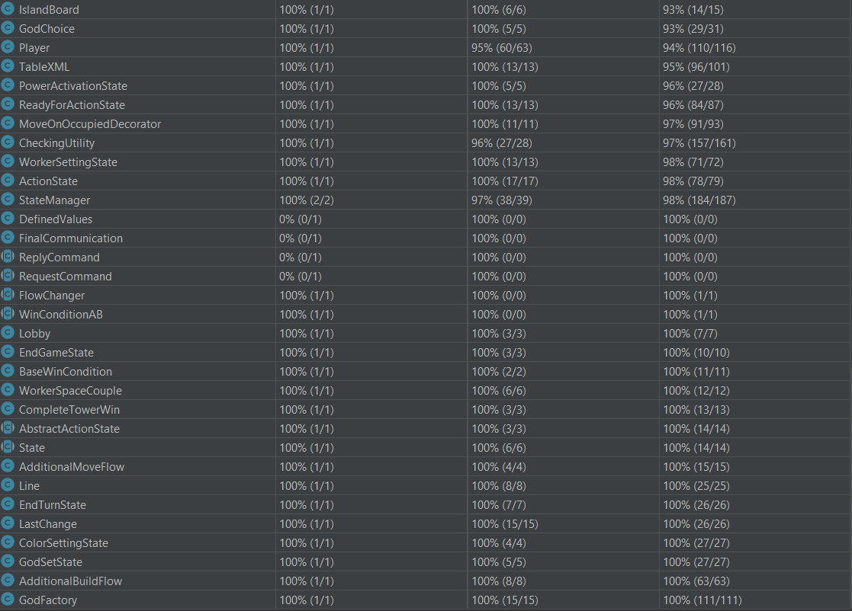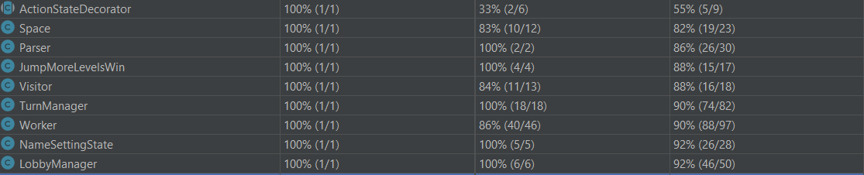

**CRITICAL ISSUES**

1. In our tests with terminal it very rarely happens that GUI throws NullPointerException because of JavaFX library (probably it doesn’t load the scene).
2. Sometimes the server/client while running the jar from terminal gets stuck, to continue it’s necessary to press ENTER or in GUI resize the window.
3. If quit button is pressed twice JavaFX generates an error because it doesn’t close fast enough.